250-832-6477 | 1-888-632-6477

[sales@validmfg.com](mailto:sales@validmfg.com) | [www.validmfg.com](http://www.validmfg.com/)

VALID INFOTAINMENT SYSTEM

**SOFTWARE UPDATE INSTRUCTIONS**

# Introduction

This document describes how to carry out a software update to the Valid Infotainment System, also referred to as the CCI (Valid Center Console Interface).

This update pertains to all 2023, 2024, and 2025 Anthem and Cornerstone models. There are two ways to obtain the software update files:

* Follow the instructions below to download the files from the web (fastest procedure).

**NOTE** A USB thumb drive in FAT32 format is required.

* Request a USB thumb drive pre-loaded with the software. To do so, email [customersupport@validmfg.com,](mailto:customersupport@validmfg.com) stating your coach serial number and shipping address.

# Procedure

To update the Valid Infotainment System software with the web download, follow these instructions.

**NOTE** To prepare, insert a FAT32 format USB storage drive into the USB port of your PC or laptop.

## Verify Current Software Version

Determine the current software version installed in the Valid Infotainment System.

1. On the Valid Infotainment System interface, press the Settings icon on the lower right corner of the touchscreen.
2. Press the Settings icon on mid left of screen (second icon from the left).
3. Press **System Information** (fourth option down).
4. Verify that the **Revision** line (second down) is less than 0.6.22 for MY2023-2024, or 0.0.30 for MY2025. If it is, continue to the procedure below.

## Software Update Instructions

1. On your PC / laptop, go to the relevant URL to download the update files. Refer to the table below.

|  |  |
| --- | --- |
| **Coach Model** | **Download URL** |
| MY23-24 Aspire | <https://help.validmfg.info/display/q1zpCq4D> |
| MY23-24 Cornerstone/Anthem | <https://help.validmfg.info/display/bPN8zxjO> |
| MY25 Cornerstone/Anthem | <https://help.validmfg.info/display/gDyUhIuy> |
| MY25 Aspire | <https://help.validmfg.info/display/KWxRC1An> |
| 2025 Cornerstone FCCC | <https://help.validmfg.info/display/MfHM7tke> |

1. Select the link from the above table to download the file for your coach and wait for the download to complete.
2. Navigate to your Downloads folder.
3. UnZip the files
4. For MY25 Copy these 3 files to a (FAT32) USB drive:
   * validmfg.autoupdate
   * validmfgupdate-v0.0.30.swu
   * VEC13A056-**\*\***.swu ( select the appropriate part number from the above table for your Coach model)

For MY23/24 Copy these 5 files to a (FAT32) USB drive:

* + validmfg.autoupdate
  + Update-complete.bgra
  + Update-in-progress.bgra
  + validmfgupdate-v0.6.22.swu
  + VEC13A056-0**\***.swu ( select the appropriate part number from the above table for your Coach model)

**IMPORTANT** Ensure these files are in the root of the USB drive - they cannot be inside a folder.

1. Remove the USB drive from the PC / laptop.

## USB drive plugged inUpdate Coach

1. Insert the USB drive into the USB port on the driver’s side console.

The update process starts automatically.

**NOTE** If you are using a lighted USB drive, the light should flash to indicate that the files are downloading to the coach.

1. When the update has finished, a message will display: Please remove USB key to finish update.

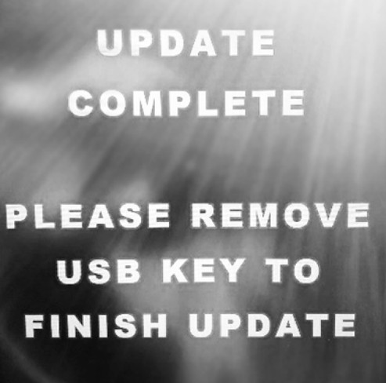

1. Remove the USB drive.

The screen will reboot on its own and return to normal operation.

## Update Network Devices

Any additional updates required for connected network devices can be done on the Valid Infotainment System screen.

1. After the screen has restarted, navigate to **Settings** > **Settings** > **System Information**.
2. Select **Network Devices**.
3. For any devices that have an Update button, press **Update** if the version is older / lower than the latest.

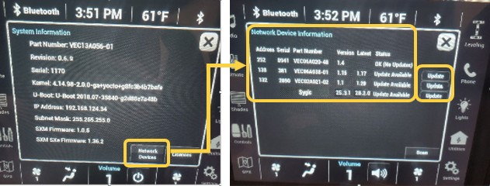

**NOTE** Ignore the Update button if the version is the same as the latest.

# Update Cobalt Cube

**IMPORTANT** Ensure there is sufficient coach power to prevent power loss during the update.

**NOTE** As long as the house battery switch by the vehicle entry door is turned on, the Cobalt Cube will remain powered on when the ignition is off.

## Download Files

1. On your PC / laptop, go to the relevant URL to download the update files. Refer to the table below.

|  |  |
| --- | --- |
| **Coach Model** | **Download URL** |
| Aspire/ Cornerstone / Anthem | [**https://help.validmfg.info/display/X0DeVxHJ**](https://help.validmfg.info/display/X0DeVxHJ) |

1. Select the link and download the CubeUpdate(v8.3.6).zip file and wait for the download to complete.
2. Navigate to your Downloads folder.
3. UnZip the the download file
4. Copy the folder CubeUpdate to a (FAT32) USB drive, it will contain two files:
   * Cubeversion.txt
   * Update.zip
5. The CubeUpdate folder must be at the root of the USB drive. **Do not** unzip the Update.Zip file
6. Remove the USB drive from the PC / laptop. A screenshot of a computer

   Description automatically generated

## Update Firmware

1. Insert the USB drive into the USB port on driver's side console.
2. Navigate to the system information page.
3. Press the network devices icon and scan devices.
4. Press the **Update** button next to the new Cobalt Cube item.

1. The below screen will appear after selecting update in the previous step. Select “Accept”

1. The screen will automatically switch to the GPS page and the below message will appear on the screen. Once the timer counts down to zero the page will go black while the Cobalt Cube is restarting.
2. A screen of a car

   Description automatically generatedA close up of a phone

   Description automatically generatedOnce the Cobalt Cube has been restarted the below pop up will appear on the GPS page. Select “Install”

After selecting “install” the below two pop ups will appear. Please wait for the device to reboot.

1. Wait while the system update is installed.
2. The Cobalt Cube reboots again.

**NOTE** The screen will go dark for a few minutes. Do not remove the USB drive.

1. Once the installation has been completed, select **Yes** to delete the install file.
2. 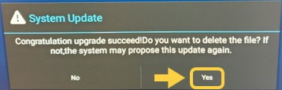The Cobalt Cube software update is now complete. Remove the USB drive

## Reboot Cobalt Cube

1. Select **GPS**.
2. Select the ellipsis (...).
3. Select the circle icon to minimize the Sygic navigation application.

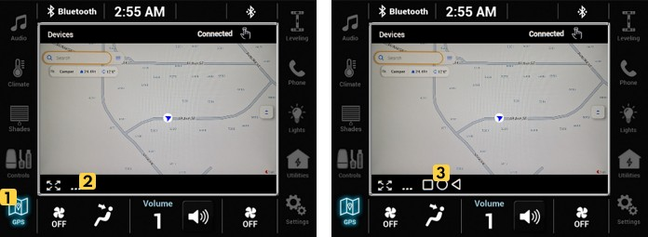

1. Select **Reboot** and **OK** to restart the Cobalt Cube.

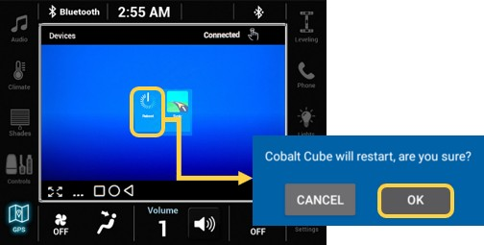

Wait for the Cobalt Cube to reboot and for the touchscreen to become active again.